VINH LONG UNIVERSITY OF TECHNOLOGY EDUCATION

**PRACTICE CENTER**

TEST PROJECT

PRACTICAL SKILLS

MODULE 4: IT SOFTWARE SOLUTIONS

MAJORS: SOFTWARE TECHNOLOGY

**Exam Paper Code: ITSS03**

|  |  |
| --- | --- |
| **SCHOOL LEADERSHIP** | **CHIEF SUBCOMMITTEE ON EXAM DEVELOPMENT** |

**Vinh Long, month 12/2020**

**GUIDE CONTESTANTS**

**Module 4: IT Software Solutions**

**Time:**

* Preparation Time: 05 minutes
* Time Duration: 150 minutes
* Break Time: 10 minutes

**Scores:**

|  |  |  |
| --- | --- | --- |
| **Exam content** | | **Marks** |
| 1 | Creating the Database | 5 |
| 2 | Importing Database Structure | 5 |
| 3 | Create Login Form | 50 |
| 4 | Managing EM Requests by Maintenance Manager | 40 |
| **Total Marks** | | **100** |

**Candidates are required to note:**

* Ensure safety standards of health and computer
* Do the test independently without discussing while doing the test
* Comply with regulations of exam room and proctor’s instructions
* Fill the information in the form
* Complete all requirements in the content of the exam
* Do not use documents, the Internet and other communication devices during the assignment
* If the exam does not have special requirement for the file name and storage location, contestants save all exam file name in the folder as following format**: D:\WorkSkills\IT Software Solutions**

***<Student’s Name>_<*** ***Student code >[.<*** ***extension >]***

**CONTENT OF THE TEST**

This Test Project proposal consists of the following documentation/files:

1. ITSS03.pdf (Session instructions)

2. ITSS03-MsSQL.sql (SQL Script to create tables with data for Microsoft SQL)

**INTRODUCTION**

Due to the large-scale expansion at Kazan Neft, the company has decided to develop an in-house maintenance management and enterprise asset management system. As part of such a system, you are required to develop a desktop application to handle emergency maintenance orders.

**DESCRIPTION OF TASKS**

While developing the test project, please make sure the deliverables conform to the basic guidelines drawn out by different departments at Kazan Neft:

* There should be consistency in using the provided style guide throughout development.
* All required software modules must have applicable and useful validation and error messages as expected by the industry.
* Offer a scrollbar if the number of records on a list or a table that do not fit in the form area comfortably. Hide scrollbars if all content can comfortably be displayed.
* The de-facto standard, ISO compliant date format is YYYY-MM-DD which will be used in this task where applicable.
* Where applicable, use comments in code to have the code more programmer-readable.
* The use of valid and proper naming conventions is expected in all material submitted.
* Any form or report once created should be displayed in the centre of the screen.
* When a form or a dialogue is in focus, operations on other forms need to be suspended.
* Provide appropriate validation and error messages throughout all parts of the system.
* The caption of Delete and Cancel buttons need to be in red to help with accidental mishaps.
* When using colors to differentiate between rows or records, there needs to be visible clarification on the screen as to what they stand for.
* The wireframe diagrams provided as part of this document are only suggestions and the solution produced does not have to be, in any way, mirror what has been pictured.
* Time management is critical to the success of any project and so it is expected of all deliverables to be complete and operational upon delivery.

**INSTRUCTIONS**

1. **Creating the Database**

Create a database by the name of “ITSS03DATA” in your desired RDBMS Platform (Microsoft SQL Server). This will be the main and only database you will use in this session. In case you are given a database by the same name, you should use the database provided by the administrators.

1. **Importing Database Structure**

Depending on your preferred RDBMS platform, a SQL scripts is made available. The said scripts consist of the database structure and data required to complete the tasks. The data needs to be imported to the database created for this session named “ITSS03”.

As instructed by the designers, the database structure provided for the purpose of this section cannot be altered. This applies to removal of tables, adding or deleting any fields on the tables or of change in their data types.

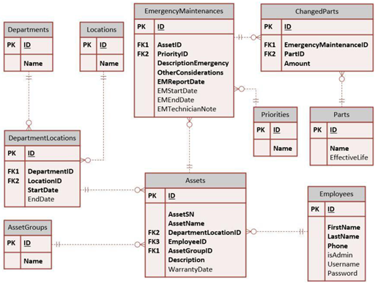

To help further perceive the thinking behind the structure of the database, the database designers provide an Entity-Relationship Diagram (ERD). The aforementioned diagram explains the conceptual and representational model of data used in the database.

1. **Create Login Form**

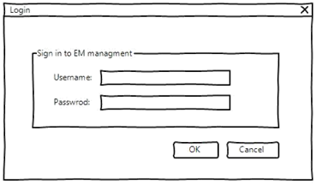

Company employees depending on their responsibilities need to gain access to the system using a form as pictured above. There are two major categories using the Emergency Maintenance system which can be described as follows:

1. Accountable Party: Each of the assets in the system need to be associated with an employee. This person will be responsible in making sure it is operational. There are no limits as to how many assets can a single employee be liable for.
2. Maintenance Manager: There are managers in the company who will look after the assets and will be following up on their maintenance jobs.

* Please note that only employees with a username may log onto the system.
* The field “isAdmin” in the database indicates whether the user is a manager (TRUE) or not.
* After a successful login the user should be directed to the proper form.

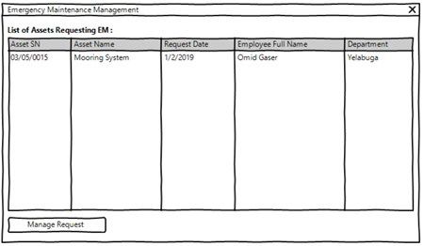

1. **Managing EM Requests by Maintenance Manager**

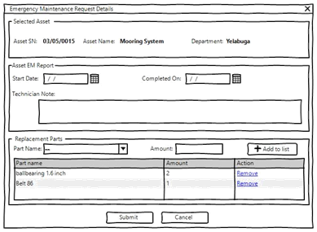

The maintenance manager after logging onto the system, may use this form to view and manage open requests registered on the system by other personnel.

* The following information need to be shown for each of the requests:
* Asset SN, Asset Name, Report Date, Employee Full Name, Department
* When a date is set under “EMEndDate” on the “EmergencyMaintenances” it specifies that the request has been completed on the said date.
* The open requests should be sorted according to the following criteria:
* First by “priority” where “Very High” goes on the top followed by “High” and “Normal”.
* Then by the date registered where the oldest is displayed first.
* By selecting a request and using the button at the bottom of the form marked as “Manage Request”, the user would be able to view and complete their information as described in the next section.